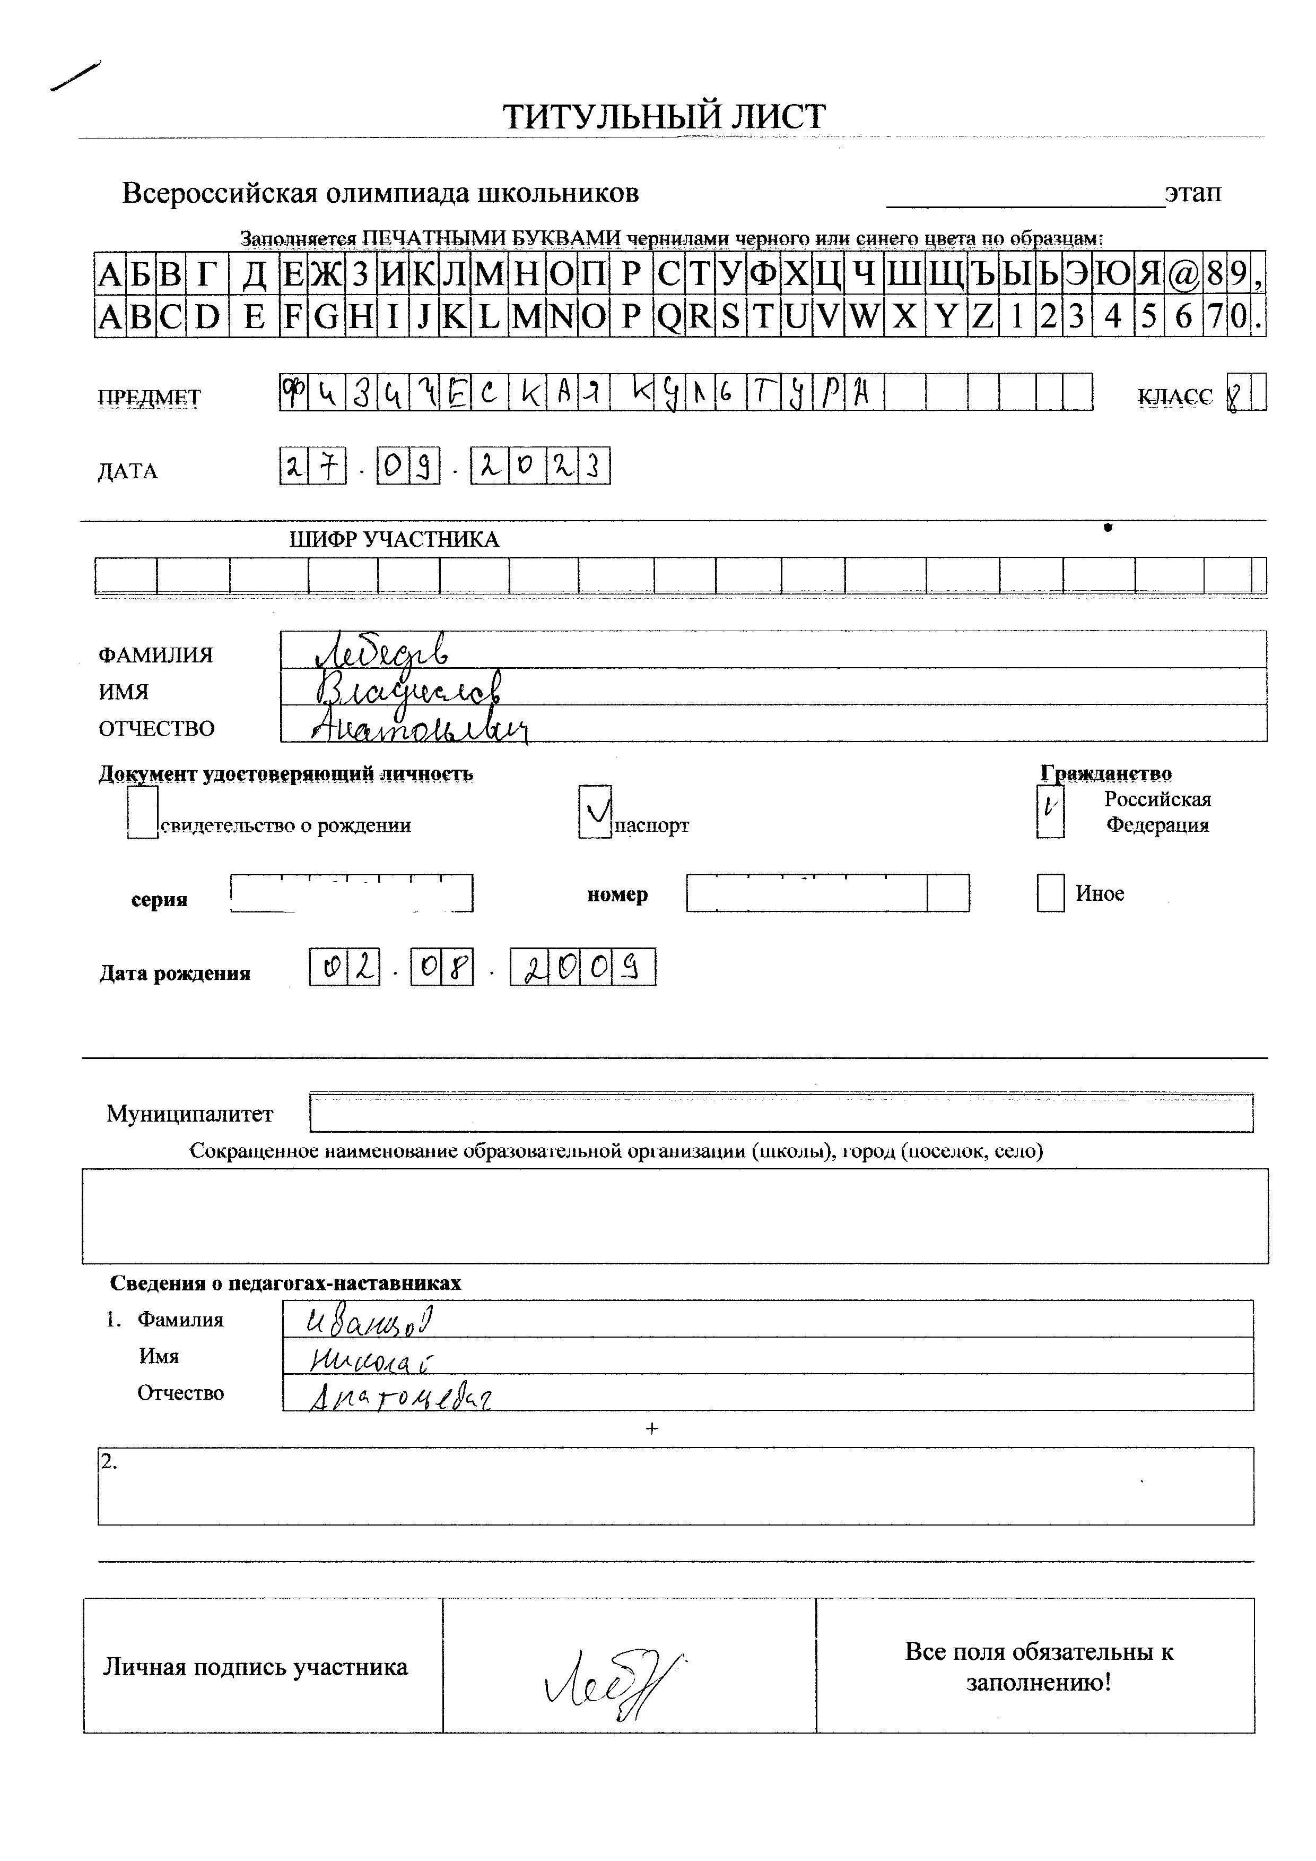

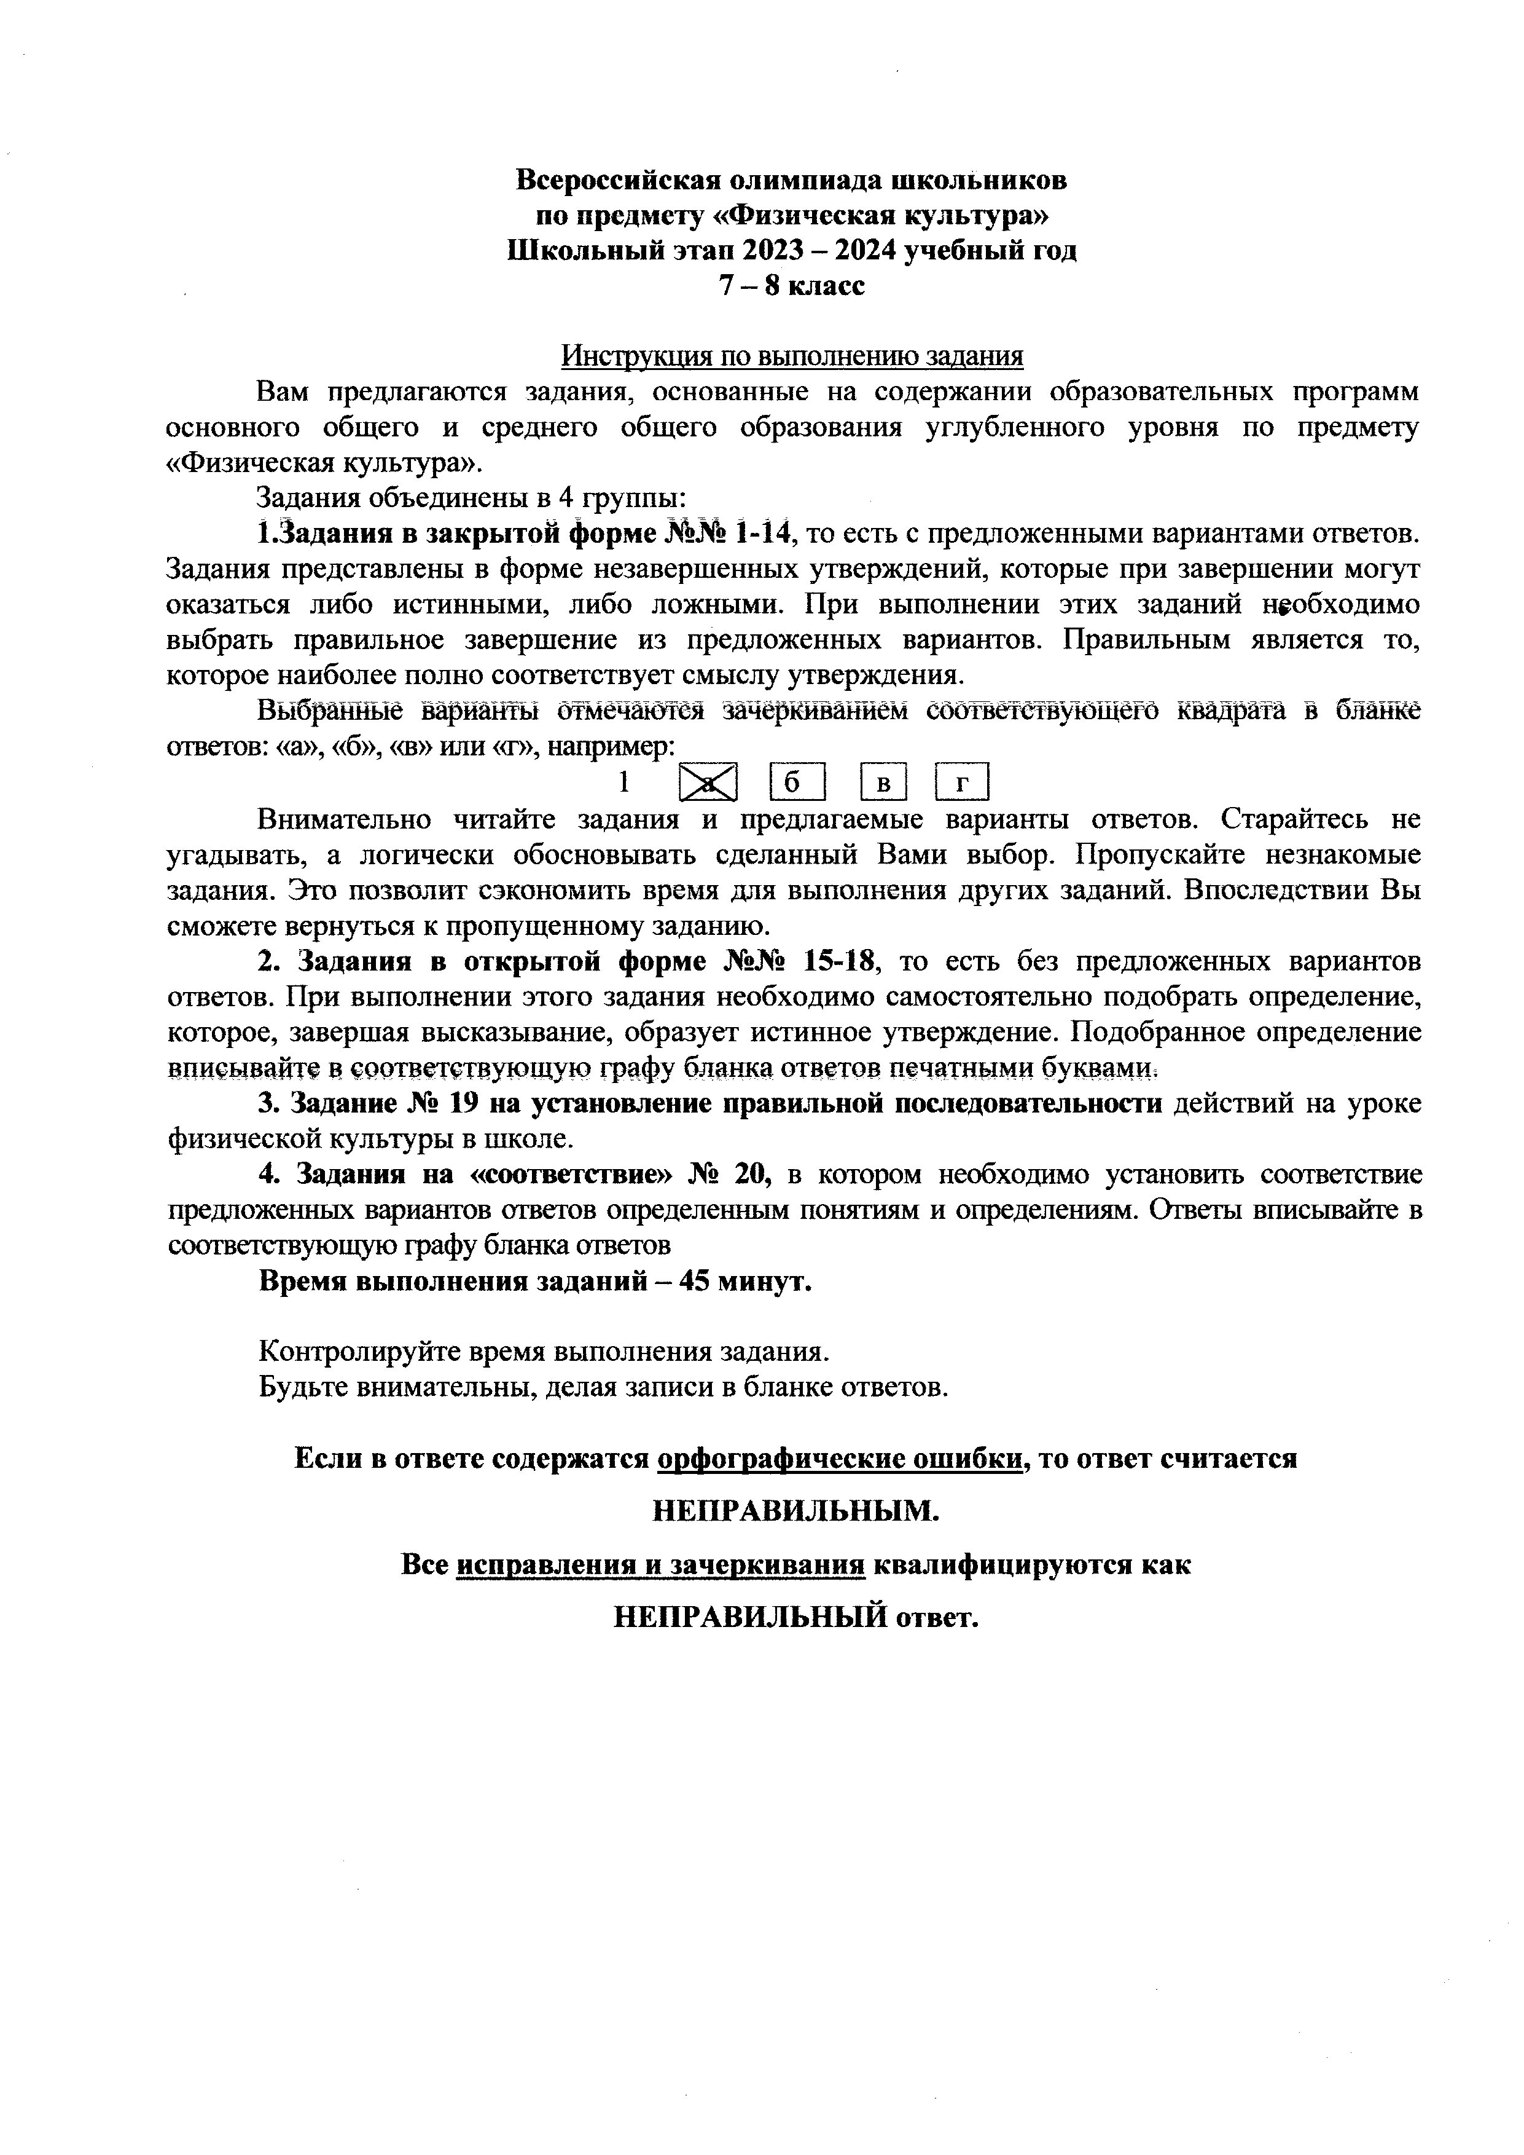

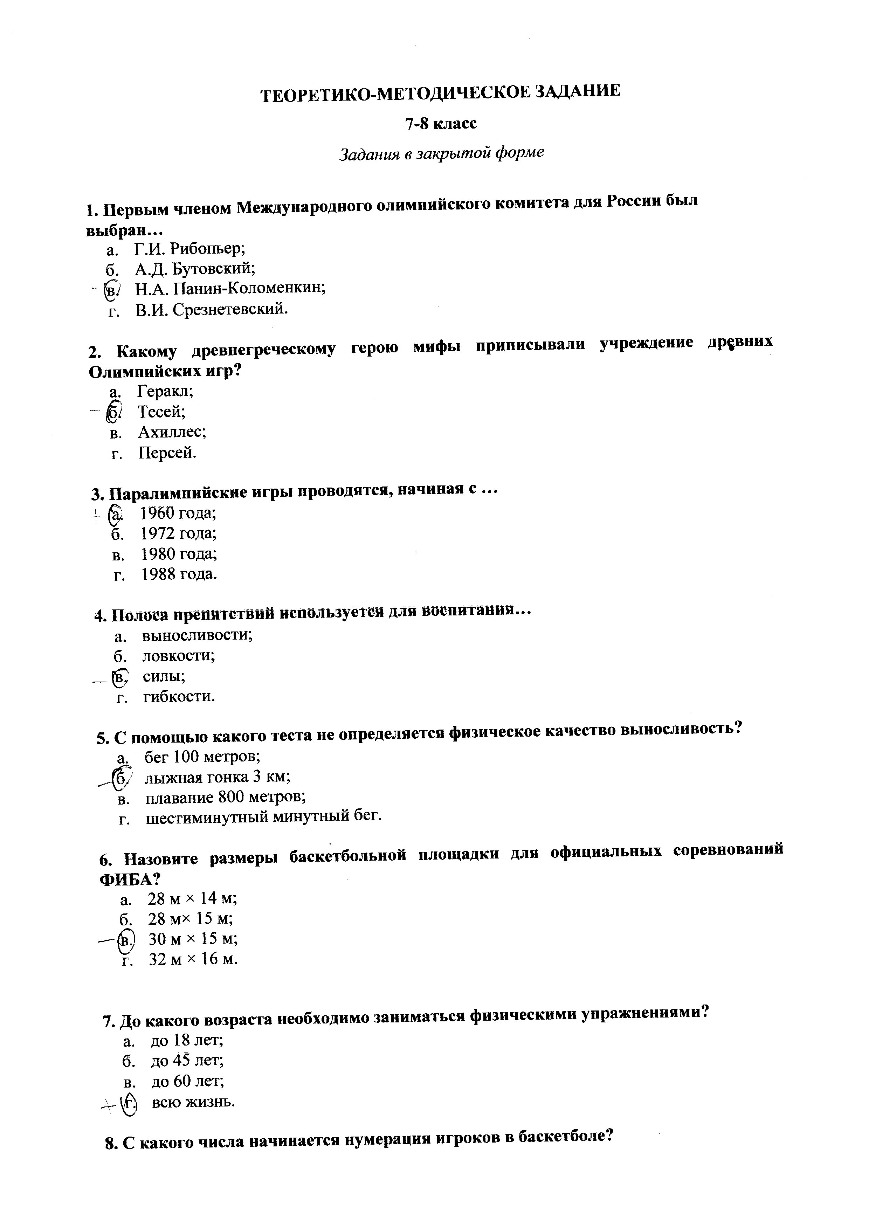

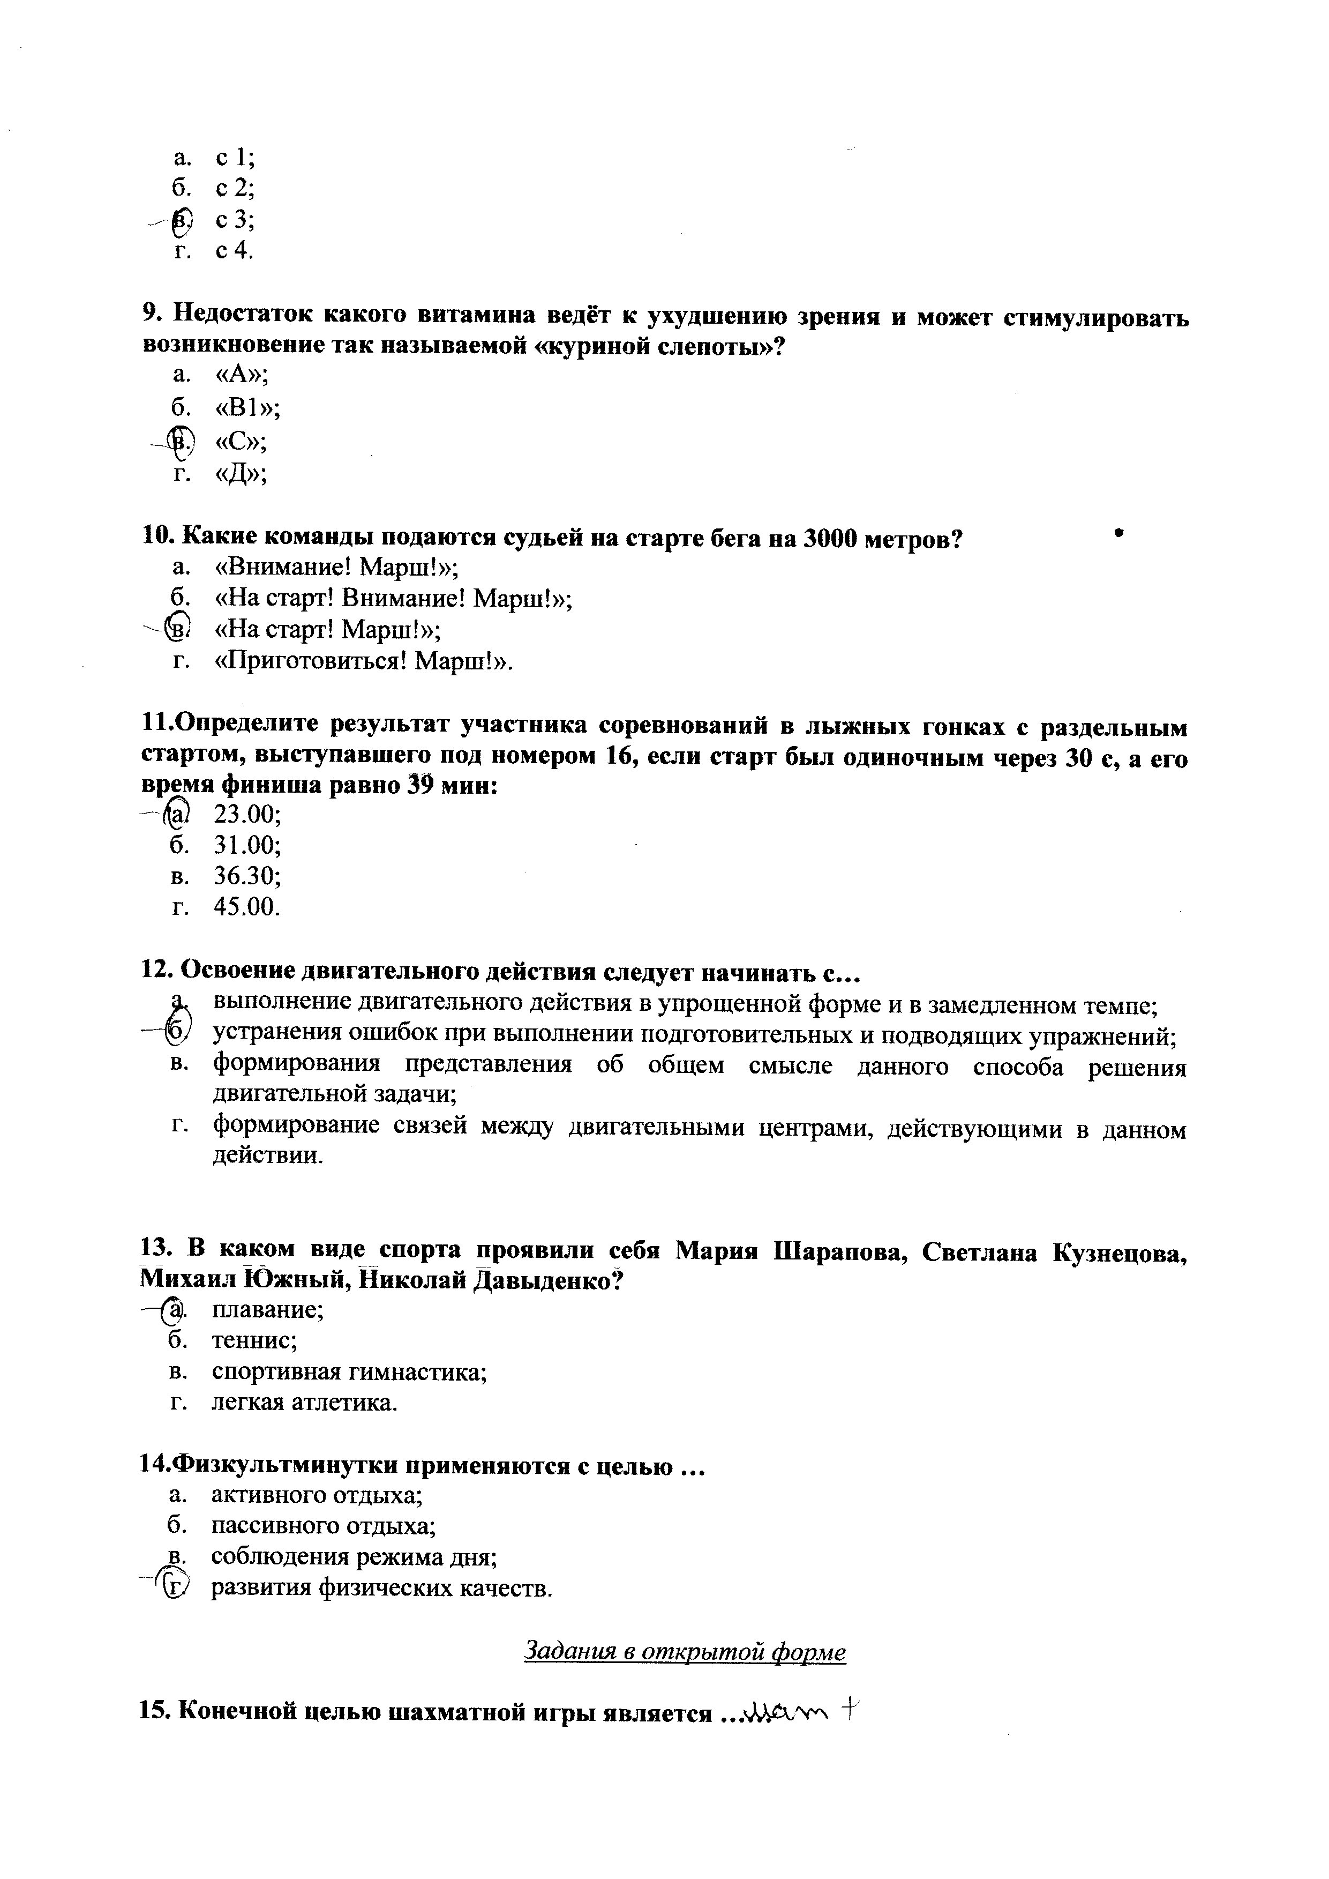

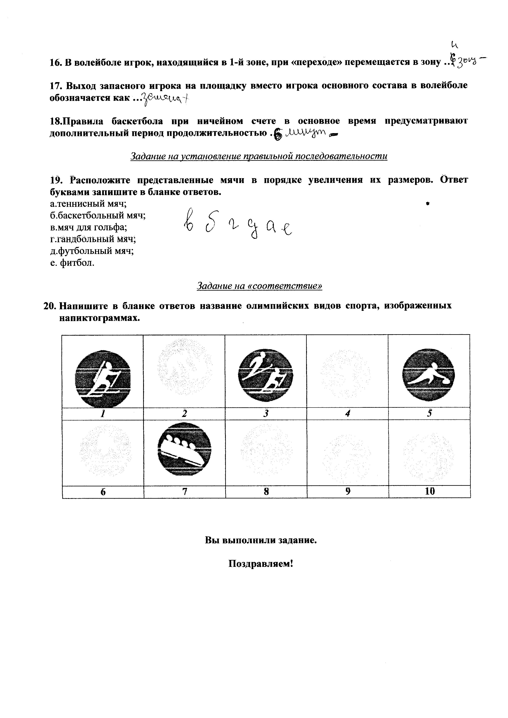

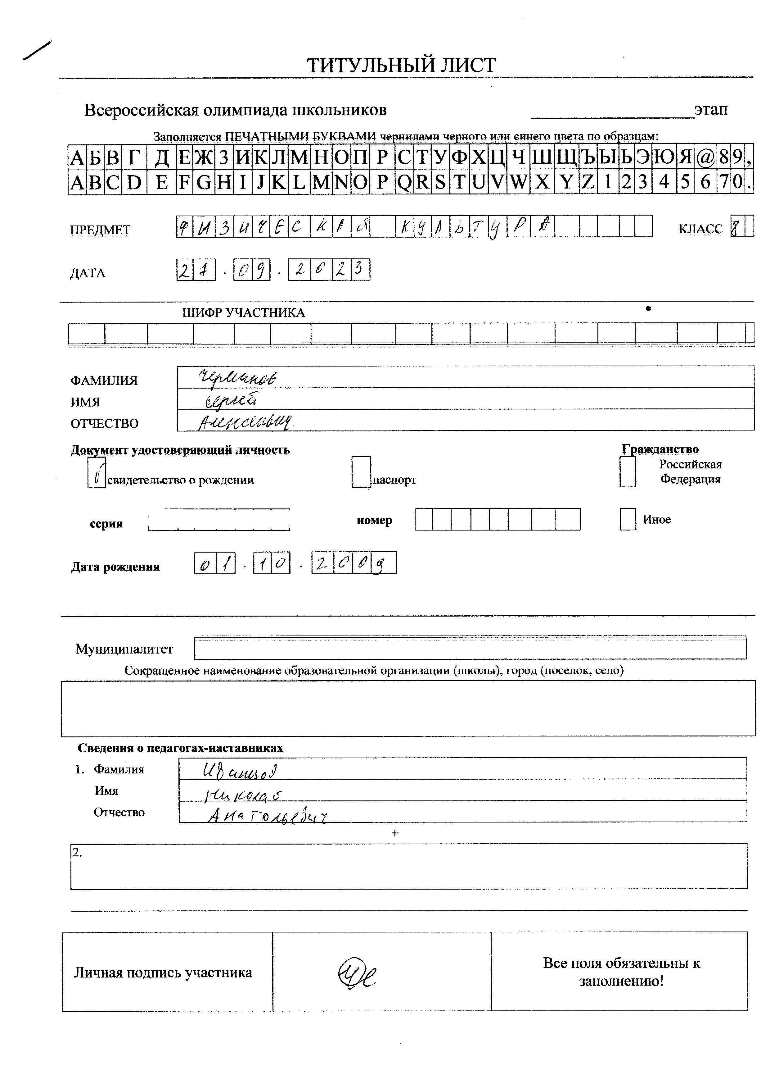

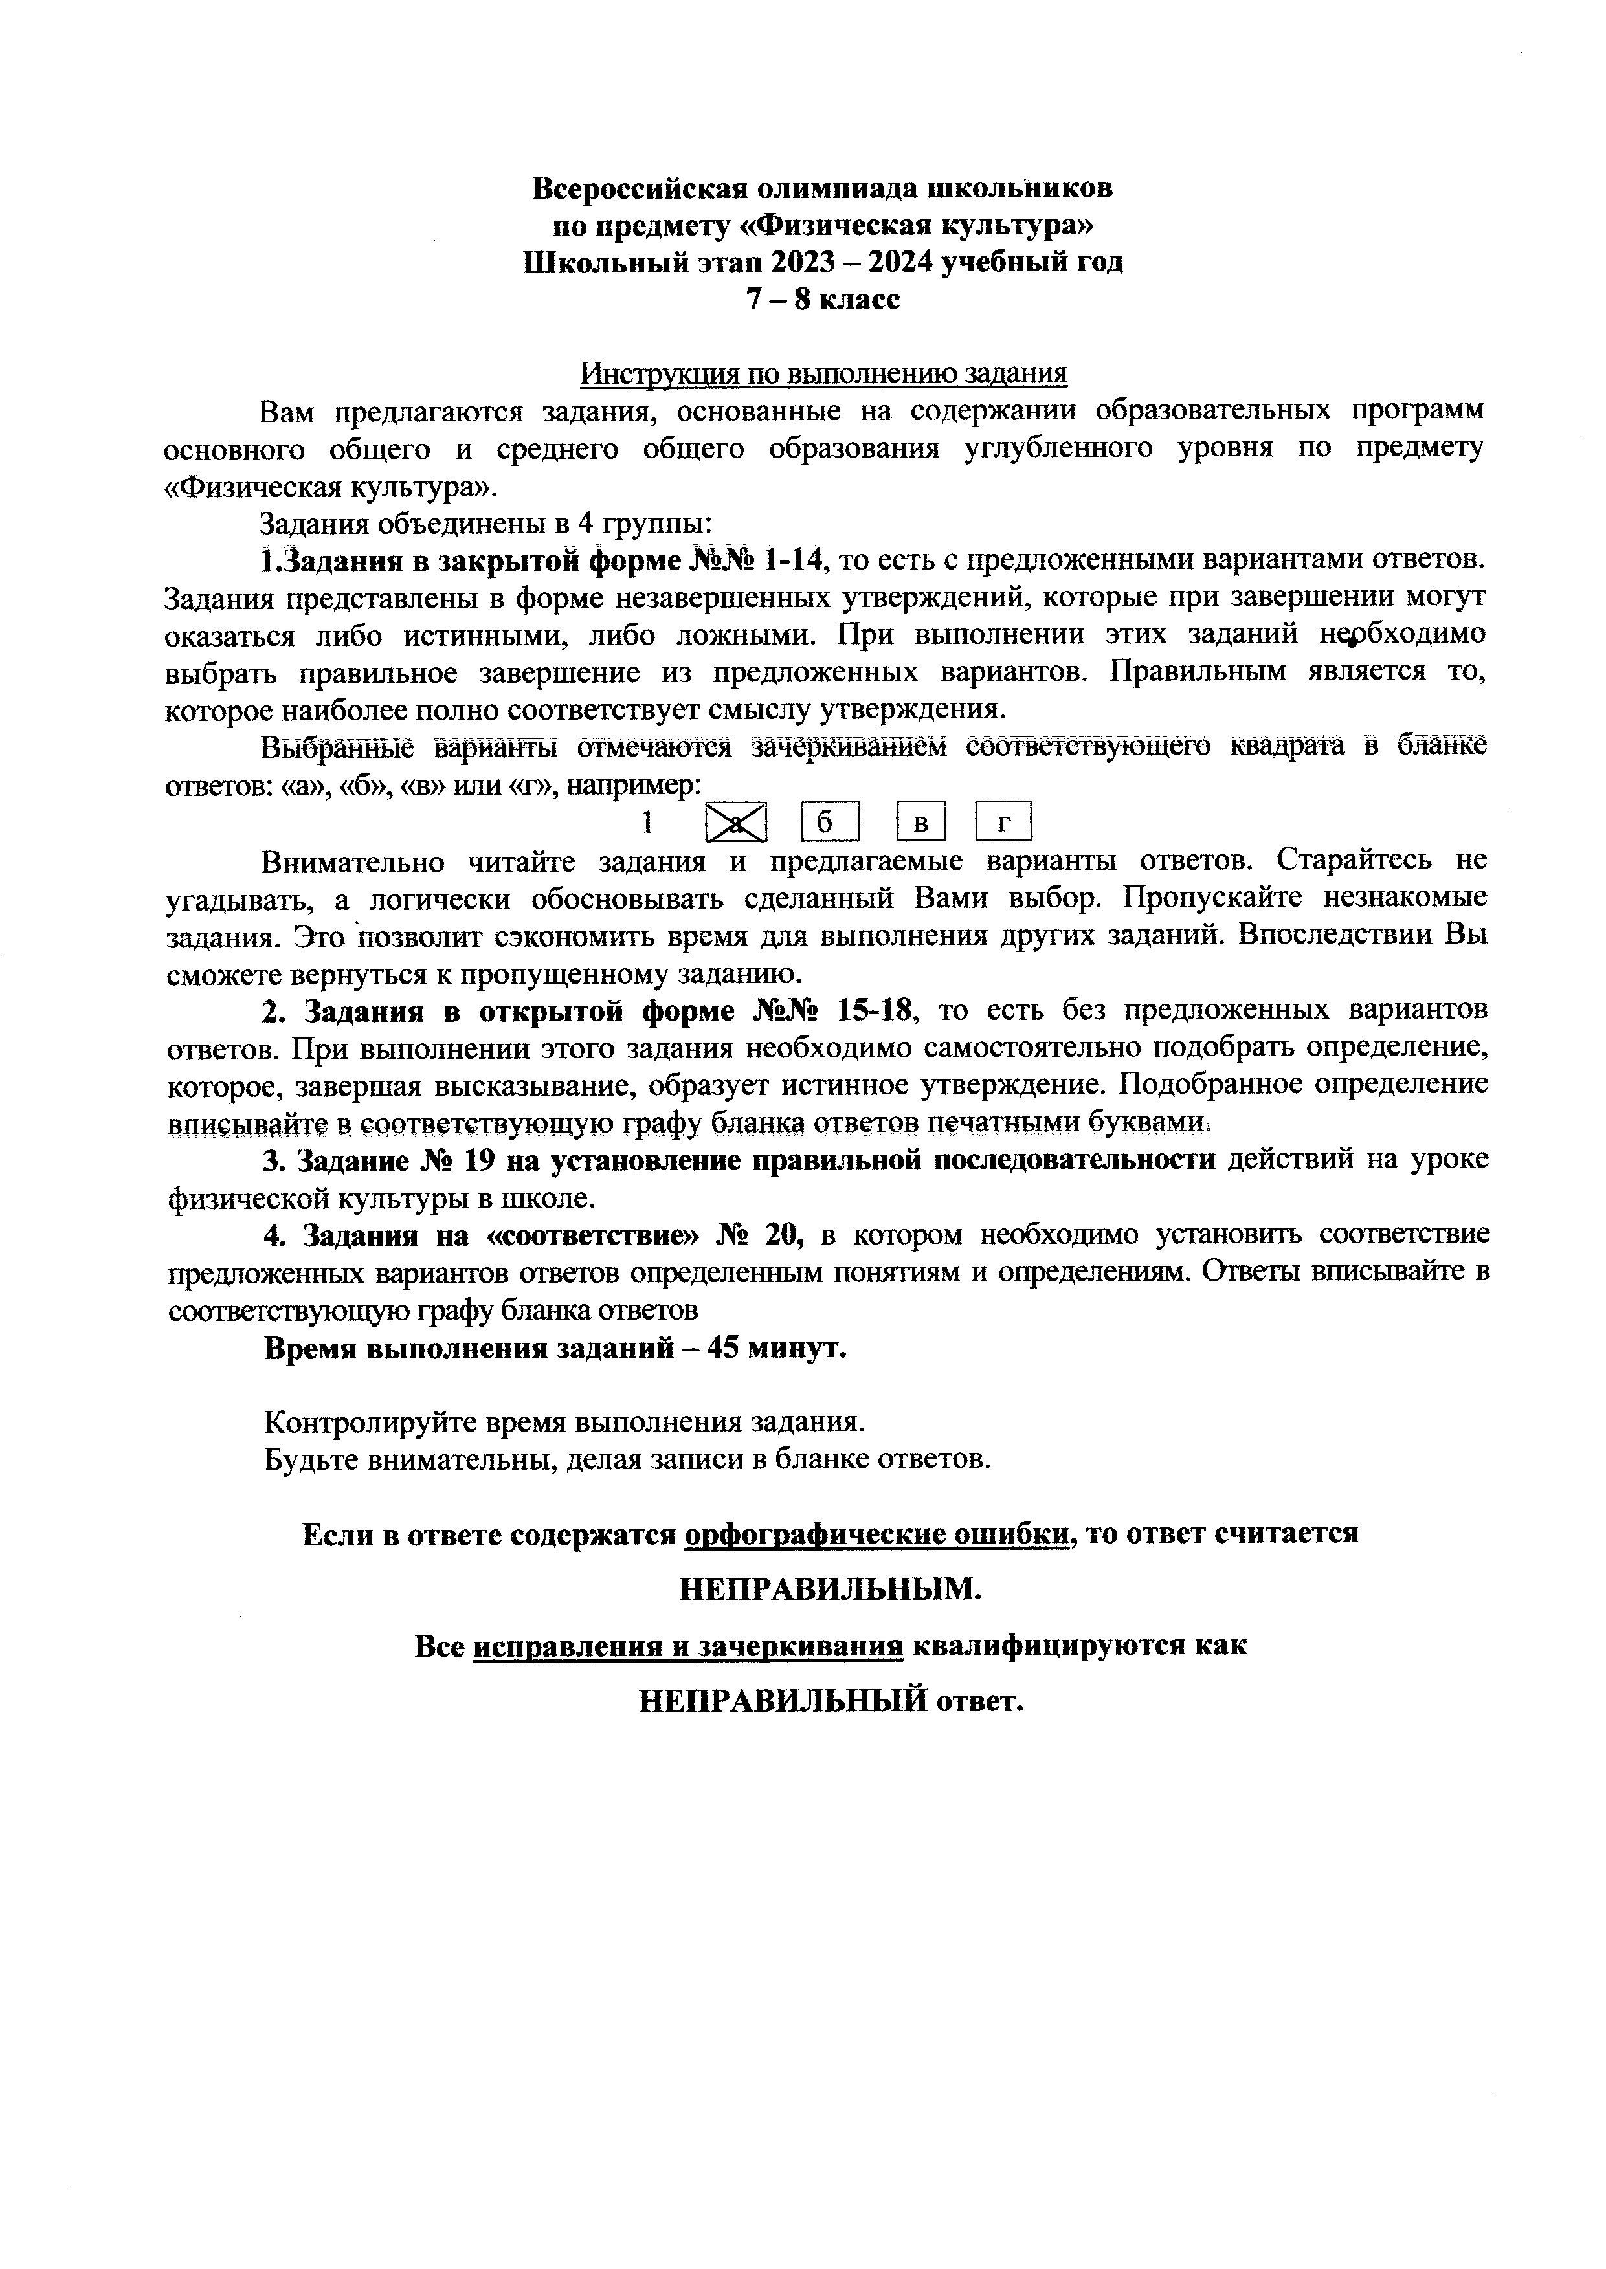

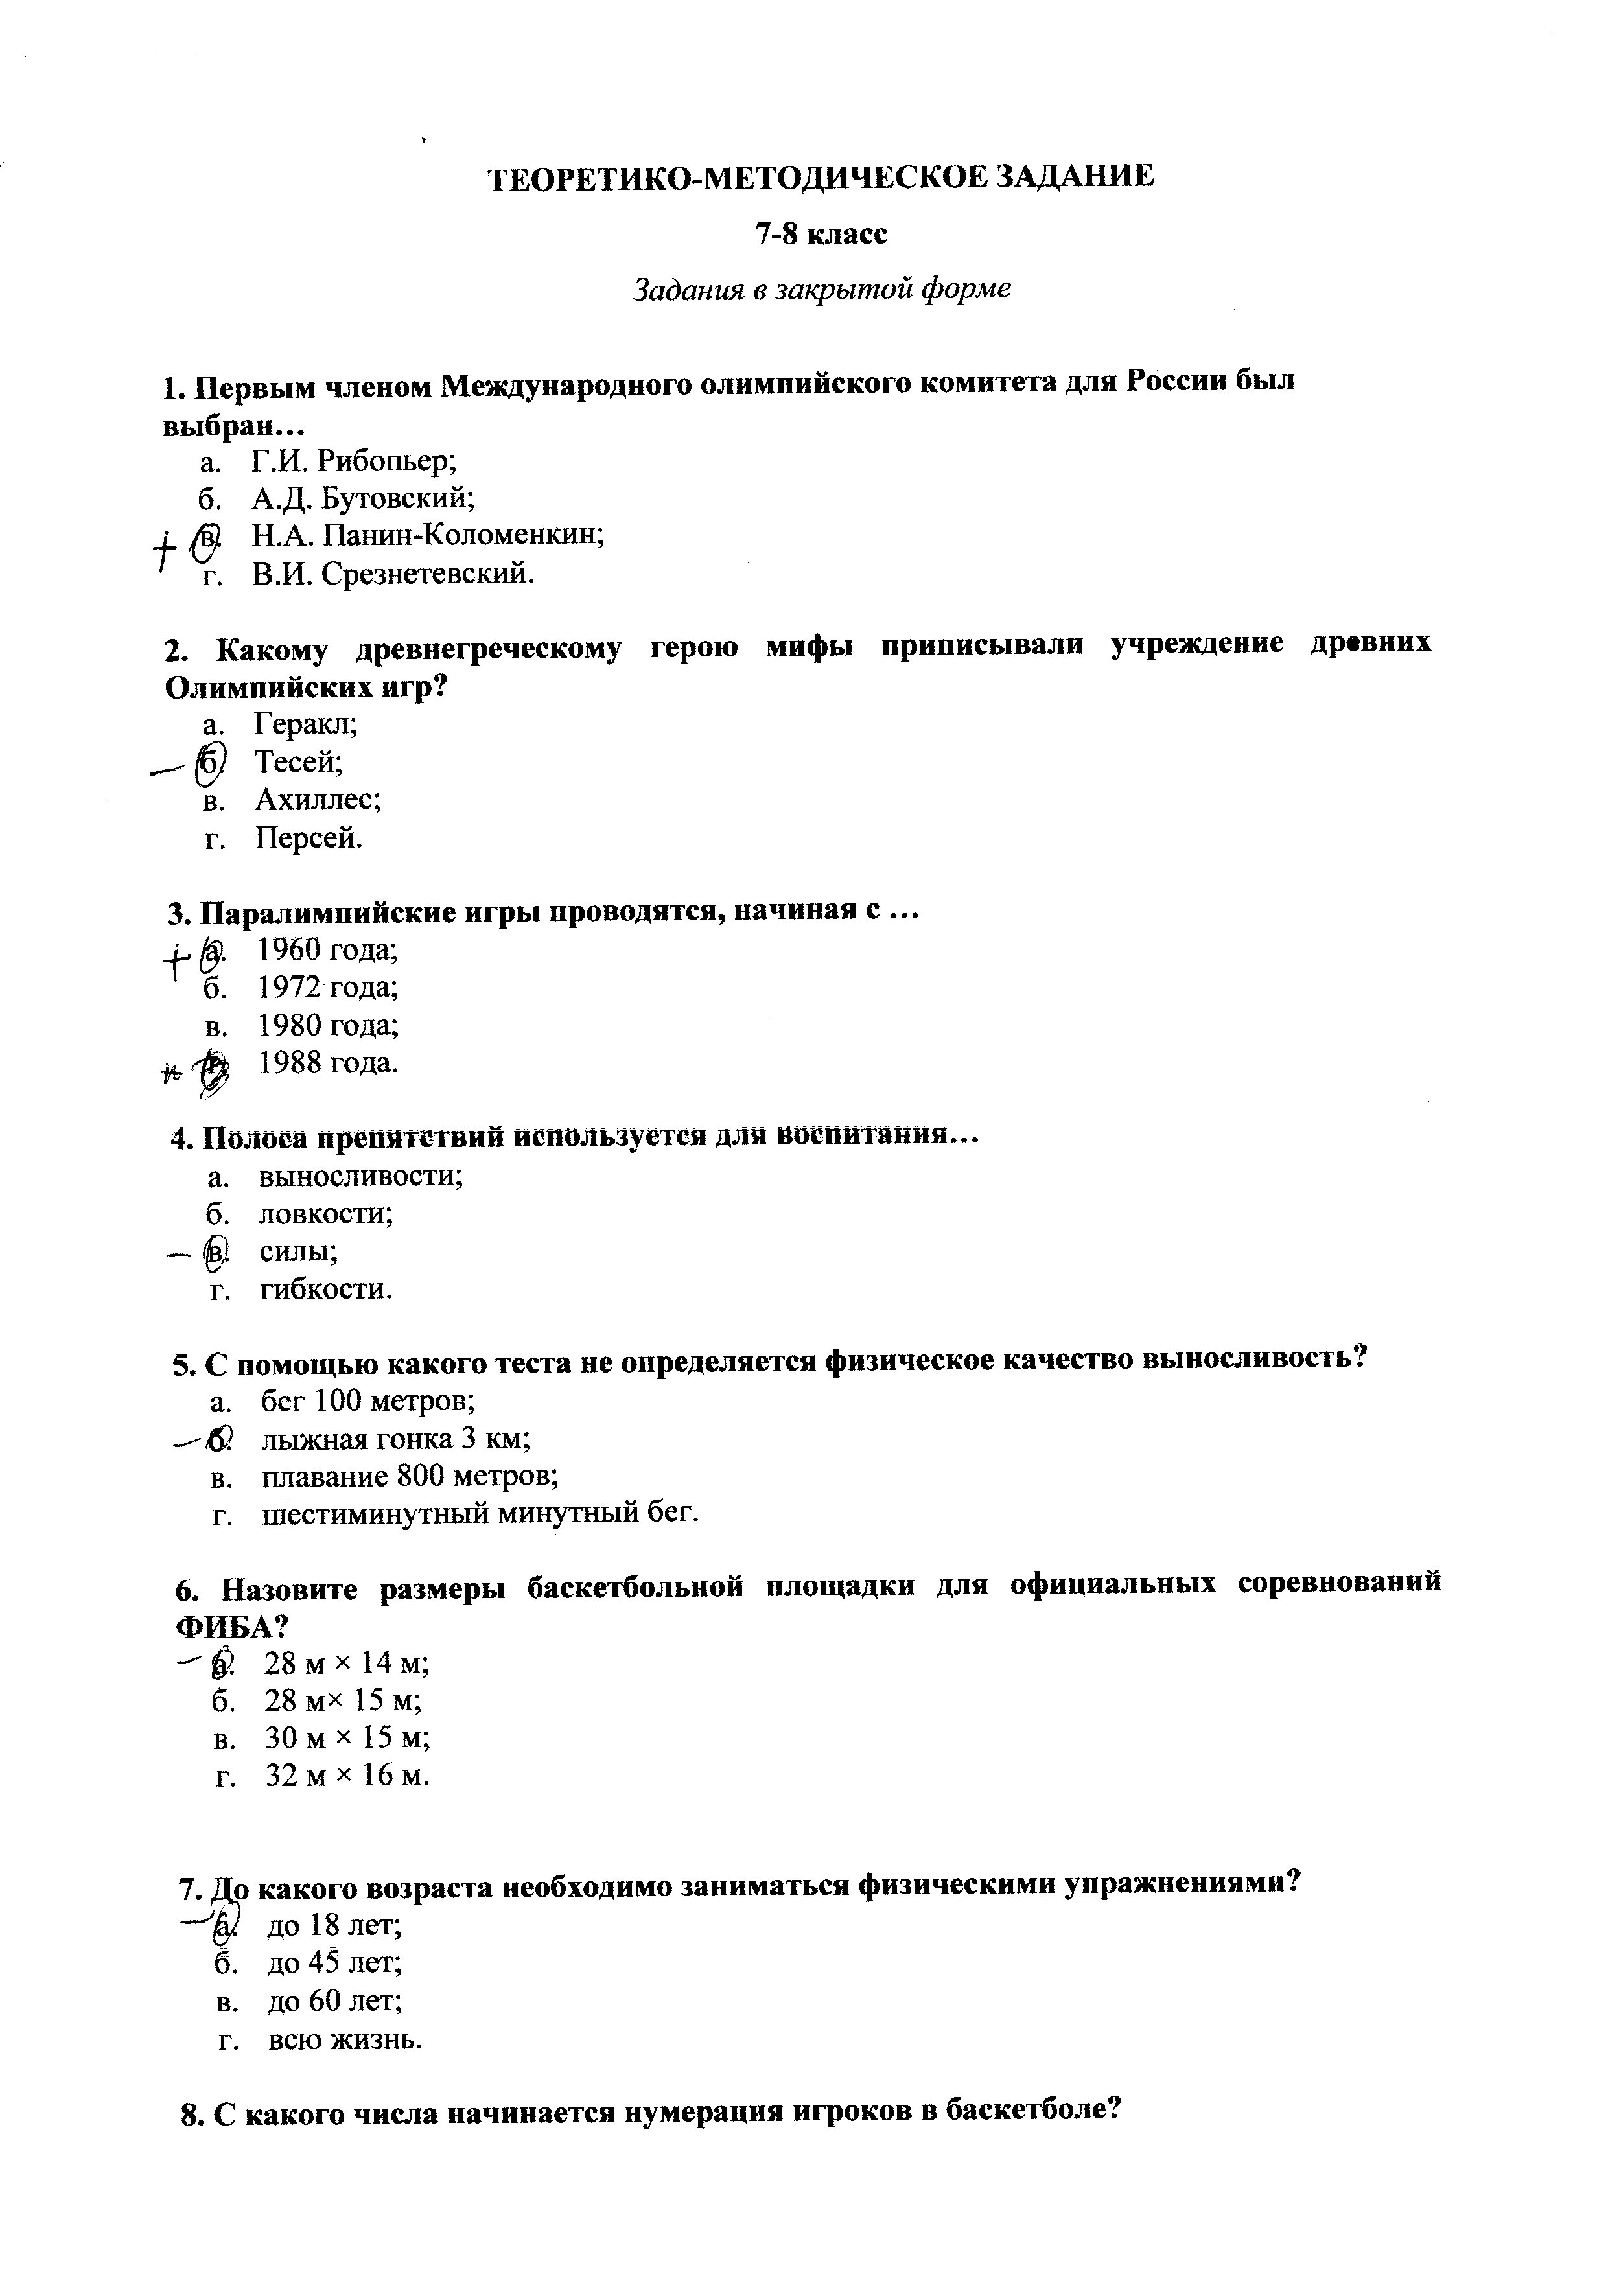

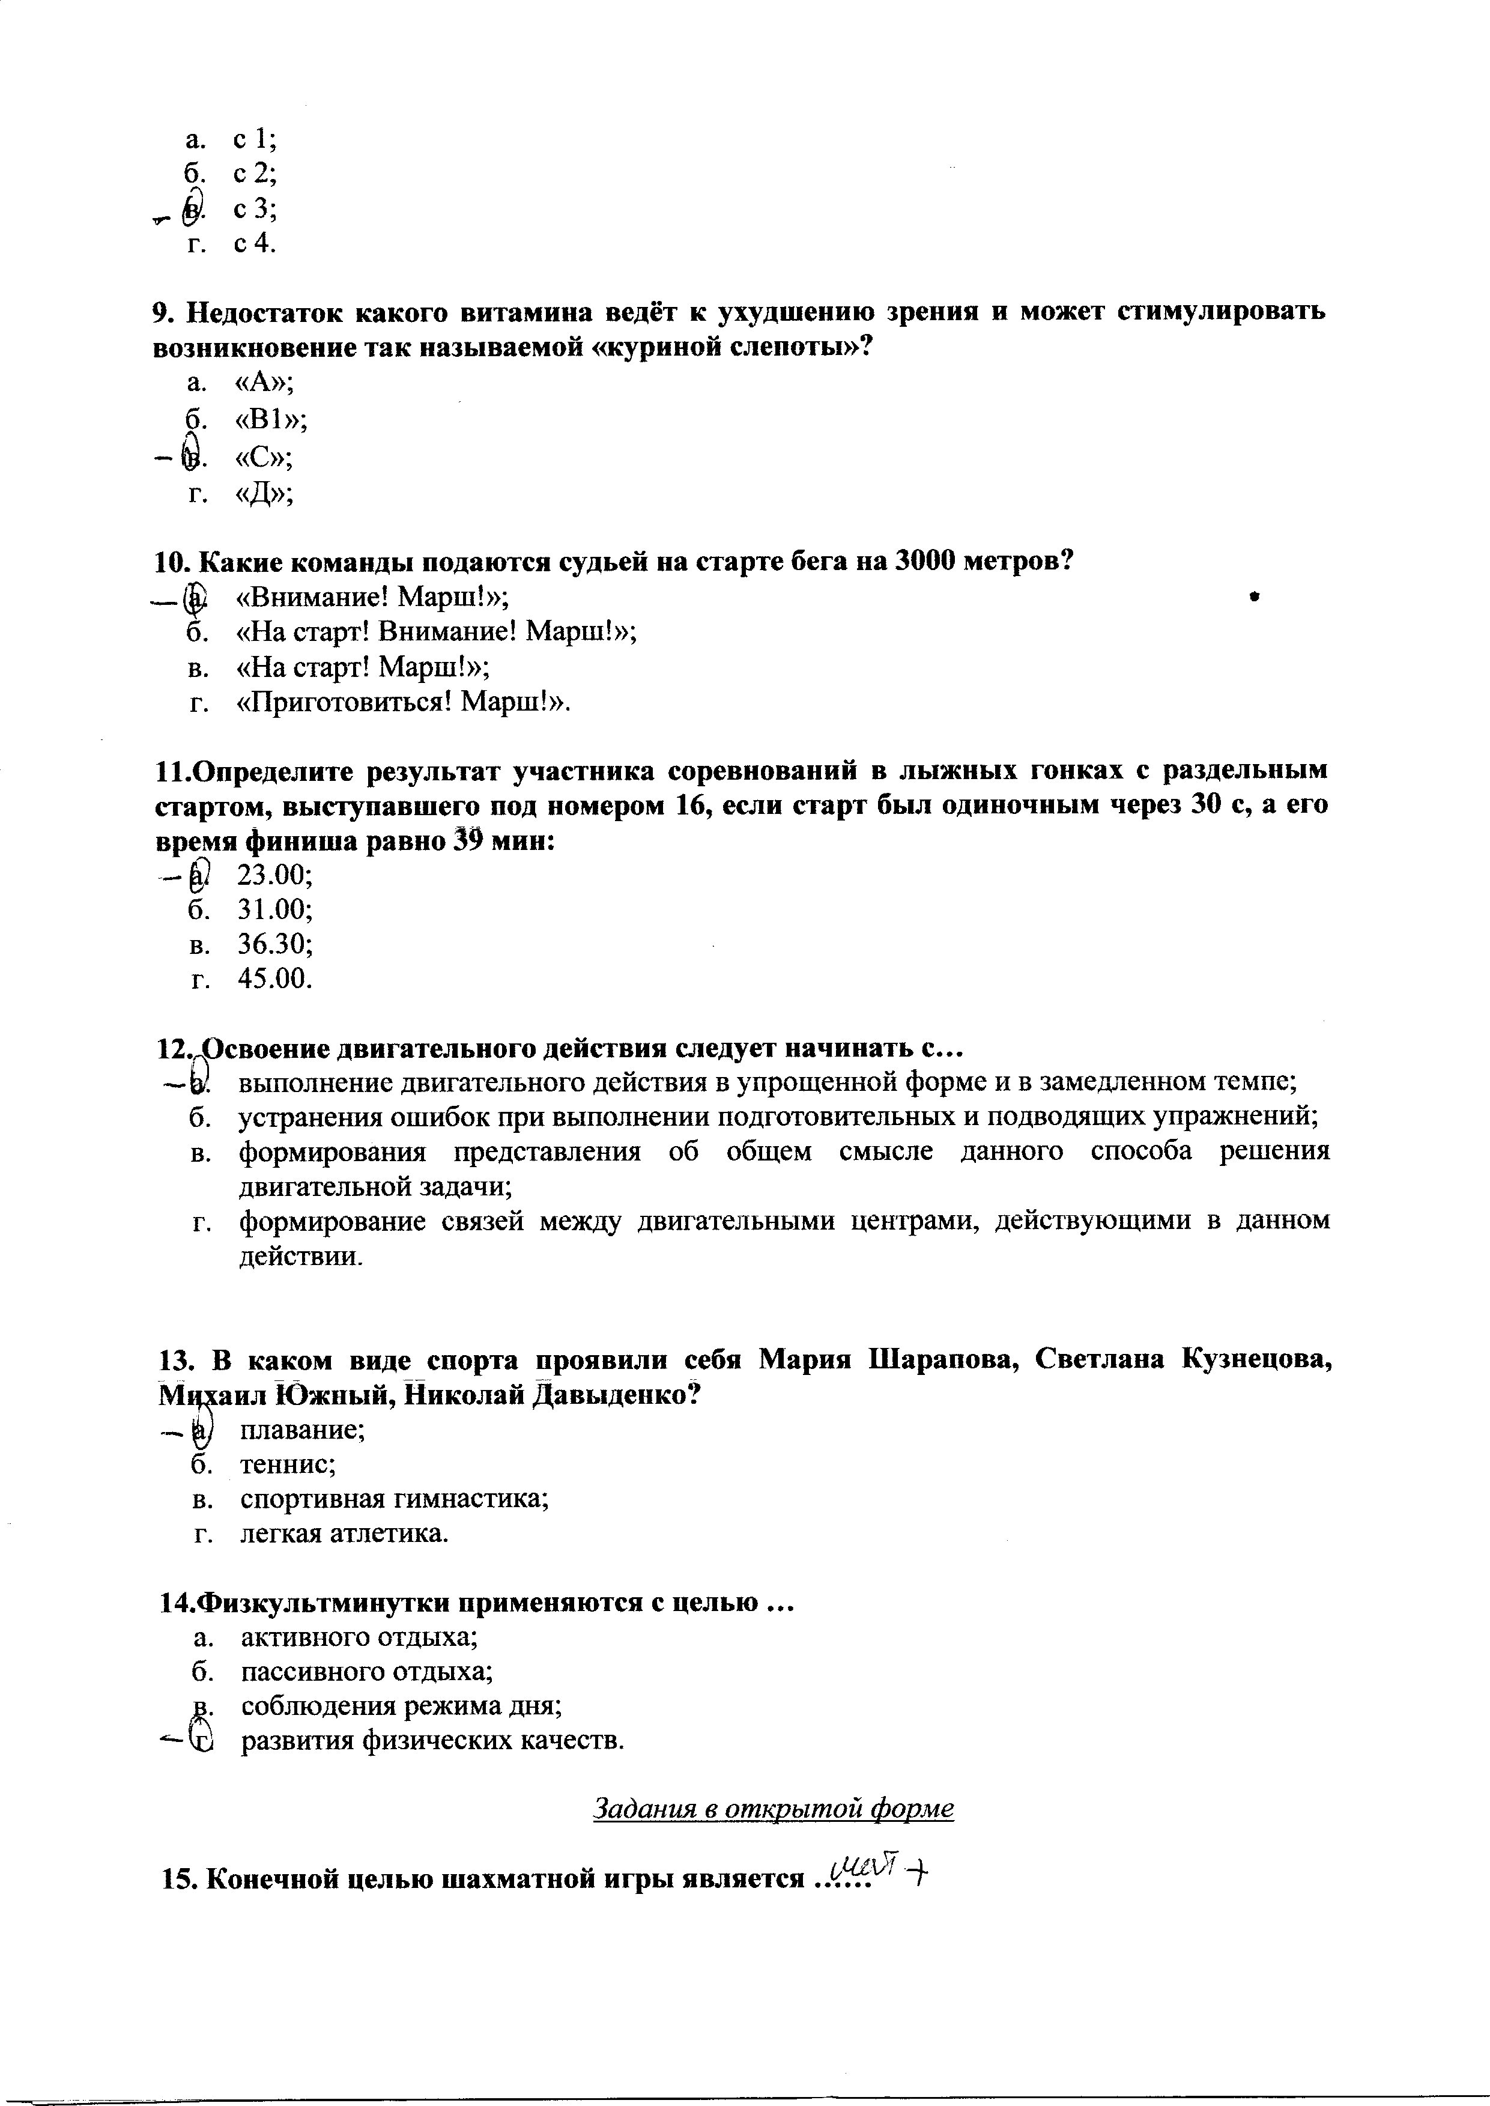

C:\Users\User\Documents\img20231207_12581913.tif

C:\Users\User\Documents\img20231207_12592059.tif

C:\Users\User\Documents\img20231207_13003101.tif

C:\Users\User\Documents\img20231207_13013327.tif

C:\Users\User\Documents\img20231207_13024178.tif

C:\Users\User\Documents\img20231207_13032978.tif